# Cloud Computing - Mini Project

**Aim**

The aim of this mini project is to. get familiar with setting up the Docker ,creating containers and deploy using a Python Hello World Program

**Part 1:**

**Installation :**

The first part of the project requires setting up Docker. Docker is an open platform for developing, shipping, and running applications. Docker enables you to separate your applications from your infrastructure so you can deliver software quickly. The Docker consists of docker platform which provides the ability to package and run an application in a loosely isolated environment called a container.

The Docker can be installed on various platforms including Windows , Linux (Any Flavor) and Mac OS . The installation is a simple process .

1.Go to Dockers official page or <https://docs.docker.com/desktop/windows/install/> and download the docker file.

2. After installing the docker address the classpath of it in your environment variables.

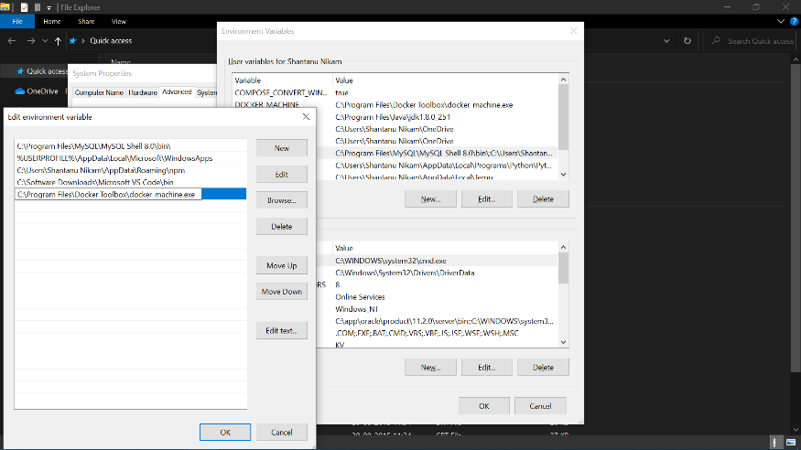

3. Simply go to command prompt of your system and type “docker -v”. If , installation is perfect it will give you some results .

**Part 2:**

**Creating our first docker file**

Let's create a separate folder for our project.

1.Open your start prompt of your windows

2.Then type Notepad and Enter

3. Type a basic Python Hello world program

print("Hello, World")

4. Save as .py extension in your desired folder

5. Create a file called DockerFile and paste this contents in it.

|  |
| --- |
| FROM python:3 |
|  | RUN mkdir WORK_REPO |
|  | RUN cd WORK_REPO |
|  | WORKDIR /WORK_REPO |
|  | ADD hello_world.py . |
|  | CMD ["python", "-u", "hello_world.py"] |

**Part 3**

**Building the image:**

Docker image is a list of dependencies and code that are needed to run your application.

We can create a docker image using:

1.Open Command Prompt from Windows start.

2. Type $ docker build -t hello_world .

Here we are assigning the name hello_world to the image.

This might take a lot of time for the first time as it has to download images from the internet.

3. Now just run the following command to see docker images:

$ docker images 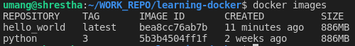

Part 4

Access the image

1. We can access the image using the following command.

$ docker run -it hello_world bash



As we can see we go to WORK_REPO that is the work directory we set.

And it has hello_world.py, which is the file we added in the docker file.

**Part 5**

**Run your Application:**

You can run the application using container id or container name. The template is: docker run <container ID| Container name>. We will use container name:

$ docker run hello_world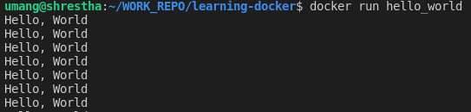

Running your application using docker

Great everything is working. But having it run in the foreground is now good for programs that need to run for a long time. In our case forever. So, close the script using ctrl + c.

**Part 6**

**Check your container :**

Containers are the run time environment for where docker runs your application based on docker images. You can check your container in your system using the command below.

$ docker ps -a

# Conclusion :

Thus, we’ve successfully learnt the Hadoop system and started

programming in Hadoop.

# OUTPUT :